I saw a bag of my roommate’s leftover M&M’s on the table, this gave me an idea - measure the M&M’s color distribution.

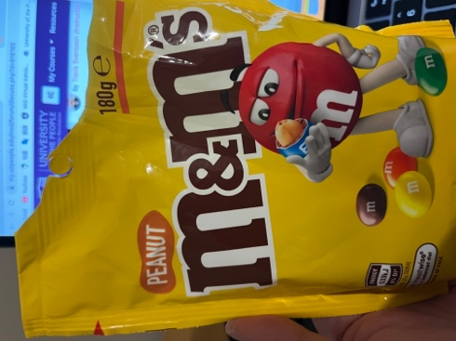

The sample space: Cyan blue, Orange, Green, Bright yellow, Red, Brown.

The rough probabilities of **M&M’S PEANUT BUTTER and ALMOND:** 20% cyan blue, 20% orange, 20% green, 20% bright yellow, 10% red, 10% brown

**What would you say to a person who says that he or she "knows" what the outcome of an individual observation will be (an outcome of something that has not happened yet that is subject to random error)?**

I would say, he might believe he would “know” the outcome from rough reference data, but there are still multiple-potential outcomes, which may be influenced by random variables.

Despite commonly reported misinformation online, each coloured M&M does **not** have a different flavour, and all possess the same chocolate taste.( M&M's. In *Wikipedia*)

I have asked my roommate, who said, “ I don’t have any M&M’s colour preferences”. But, that can be a random variable for another leftover M&M bag.

Besides, The M&M’s manufacture is a random variable for colour distribute.

M&M’S are produced at two different factories. Each factory has its own claimed distribution:

**Hackettstown, NJ**

Brown: 12.5%, Red: 12.5%, Yellow: 12.5%, Green: 12.5%, Orange: 25%, Blue: 25%

**Cleveland, TN**

Brown: 12.4%, Red: 13.1%, Yellow: 13.5%, Green: 19.8%, Orange: 20.5%, Blue: 20.7%

To find out which factory your package of M&Ms came from, check the serial code: a code that includes “HKP” was produced at the Hackettstown factory; a code that includes “CLV” was produced at the Cleveland factory.

Reference:

Wikipedia contributors. (2022, December 1). M&M's. In *Wikipedia, The Free Encyclopedia*. Retrieved 02:18, December 3, 2022, from <https://en.wikipedia.org/w/index.php?title=M%26M%27s&oldid=1125003652>

(n.d.). Color distribution for various types of M&Ms. STATE MEDIC. <https://www.statsmedic.com/m-m-distribution>

Yakir, B. (2001). Introduction to statistical thinking (with R, without Calculus). The Hebrew University of Jerusalem.